**Computer Organization Fall 2024**

**HKBU-BNU United International College**

**Lab 7: LC-3 Assembly Language**

# Lab Objective

To learn how to use the LC-3 assembler to translate the LC-3 assembly language program into machine language instructions of the LC-3.

# Introduction

**Assembly language （汇编语言）** is a low-level language that makes the programming process more user-friendly than programming in machine languages. Each assembly language usually specifies a single instruction in the ISA. An **assembler （汇编器）** is a program that translates assembly language program into machine language instructions. The translation process is called **assembly (汇编)**.

An instruction in assembly language consists of four parts:

**LABEL OPCODE OPERAND; COMMENTS**

LABEL and COMMENTS are optional. OPCODE and OPERANDS are mandatory. The OPCODE is a symbolic name for the opcode of the corresponding LC-3 instruction. For example, instead of using 0001, 0101 or 1001, we can use ADD, AND or LDR, which are much easier to remember. The number of operands depends on the operation being performed.

Pseudo-ops, or assembler directives, are helpful to the assembler in performing its task. They do not refer to operations that will be executed. Rather, the pseudo-op is strictly a message to the assemble to tell the assembler what to do in the assembly process. The LC-3 contains five pseud-ops: .ORIG, .FILL, .BLKW, .STRINGZ, and .END.

# Lab Instruction

**Step 1: Download and extract the LC-3 Simulator for Windows.**

**Step 2: Type in the following LC-3 assembly program in Figure 1 and save it as addnums.asm**

**Step 3: click on the button  to assemble the assembly language program. You will get the following files:**

**addnums.obj (the machine code)**

**addnums.bin (your program in ASCII 1s and 0s)**

**addnums.hex (your program in ASCII hex format)**

**addnums.sym (the symbol table created on the assembler’s first pass)**

**addnums.lst (the list file for your program)**

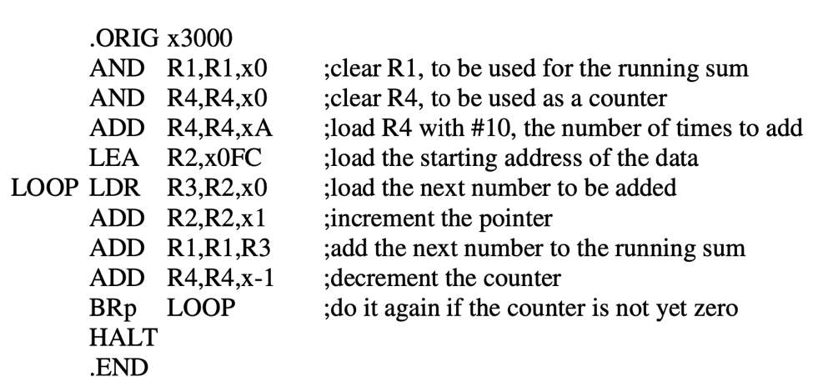

**Figure 1**

**Investigate the content of these files and figure out what they represent.**

**Step 4: Open the file addnums.sym using any text editor and you will see the Symbol table.**

**Step 5: Open the file addnums.lst using any text editor and you will see a complete list of the assembly language code along with the machine codes and other related information.**

# Lab Exercise

Assembling the following assembly program first by hand and then verify your result using the assembler. Write a report describe the assembling process. Your report file should include the symbol table and the machine code in binary for the assembly code and other related information to describe the assembling process.

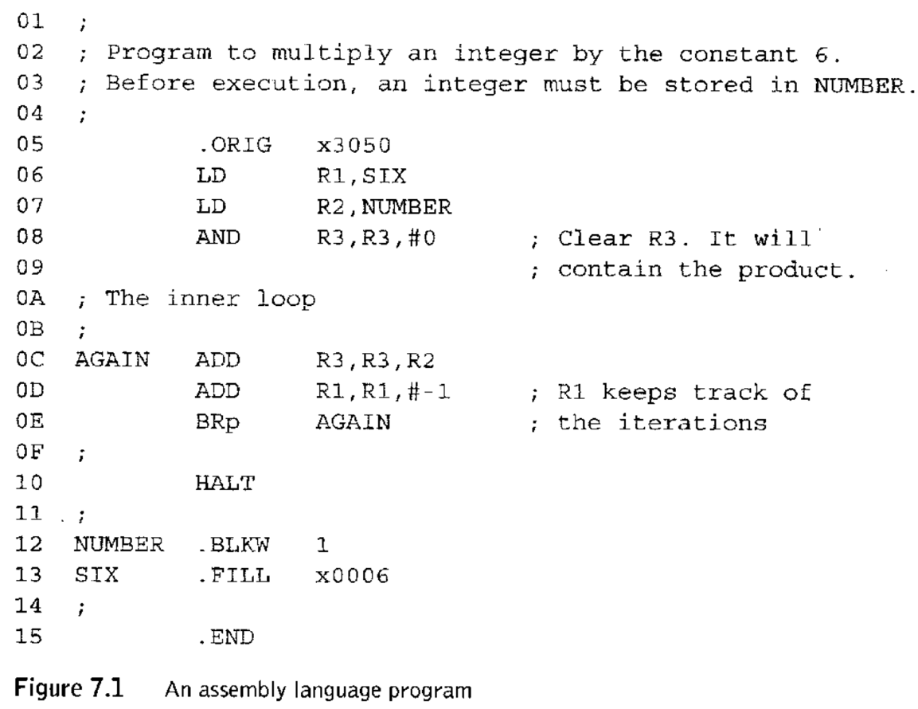

# Submission

Upload the report file (.doc, or .pdf) into ISpace. Please name the report file with your student ID.